Analysis of FM Signal using Fourier Transform

Members: Jubin Nagpal (170002022)

Satyajeet Deshmukh (170002042)

Shreyansh Thakur (170002048)  
 Sarthak Chincholikar (170003013)

horizontal line

# ABSTRACT

In telecommunications and signal processing, frequency modulation (FM) is the encoding of information in a carrier wave by varying the instantaneous frequency of the wave. We present here a frequency domain analysis of FM signals using Fourier transform (FFT). The analysis was implemented in MATLAB.

# INTRODUCTION

**FM Signals**If the information to be transmitted (i.e., the baseband signal) is  and the sinusoidal carrier is where fc is the carrier's base frequency, and Ac is the carrier's amplitude, the modulator combines the carrier with the baseband data signal to get the transmitted signal:

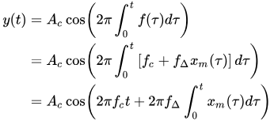

Where being the sensitivity of the frequency modulator and being the amplitude of the modulating signal or baseband signal.

**Fourier Transform**

The Fourier transform (FT) decomposes a function of time (a signal) into the frequencies that make it up. The Fourier transform of a function of time itself is a complex-valued function of frequency, whose absolute value represents the amount of that frequency present in the original function. The Fourier transform is called the frequency domain representation of the original signal. The Fourier transform of a function f(x) is formulated as follows:



# DATASET

The Dataset required for the analysis was obtained from:

<https://www.sciencedirect.com/science/article/pii/S0165168497000091>

Table: Various FM Signal Parameters are as follows:



# METHOD AND ANALYSIS

The analysis of the FM signals was performed in MATLAB using fast Fourier transform (fft). Signal was first sampled in time domain. Then fft was applied to obtain Fourier transform of the signal.

**Code Snippet**

clc;

clear all;

close all;

Fs = 10000; % Sampling frequency

T = 1/Fs; % Sampling period

L = 15000; % Length of signal

t = (0:L-1)*T; % Time vector

S = 15*exp(1i*0.9317)*exp(1i*(2886*t + 0.10*sin(338*t))); % FM Signal

Y = fft(S); % Taking fft

P2 = abs(Y/L);

P1 = P2(1:L/2+1);

P1(2:end-1) = 2*P1(2:end-1);

f = Fs*(0:(L/2))/L;

plot(f,P1) % Plotting the fourier transform

title('Single-Sided Amplitude Spectrum of X(t)')

xlabel('f (Hz)')

ylabel('|P1(f)|')

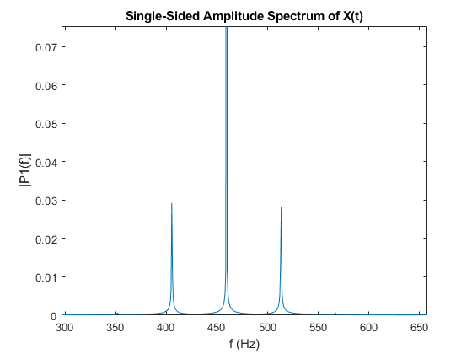

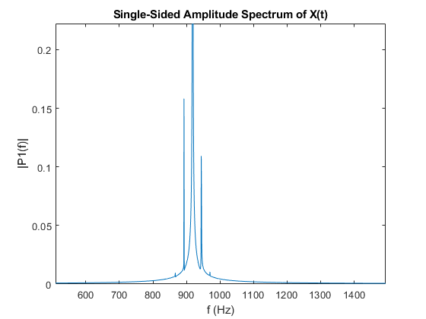

# 

# CONCLUSION

After successful completion of the above steps and the implementation of the above mentioned code, we conclude from the Fourier analysis that the energy of the signal is contained within the range fc ± fΔ. The frequency spectrum has components extending infinitely, although their amplitude decreases, therefore they can be neglected. With the change in the values of the parameters of the FM signal, the spectrum shifts as observed above.